Expires:
DEC
2025



PRICING GUIDE ( For Our In-Stock Items )

Your Sales Representative is: Kevin Broberg

Call for product details and to place your order today: 907.351.1271
E-Mail: SupplyingAlaska@gmail.com
Visit us at www.TrustySupply.com for more information

Cleaning Made Simple, Affordable, and Effective

ABOUT US
We offer a wide range of chemicals, equipment, and services to help you keep your business clean and functional. Our team of experts are dedicated and available to provide you with the right products and services for your industry.
CHEMICALS________________________________________________________________________
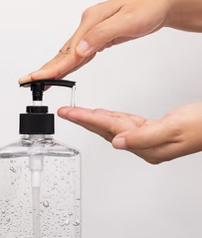
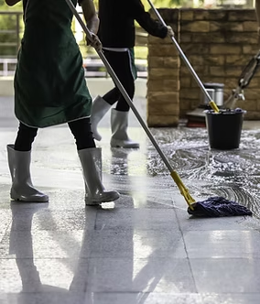
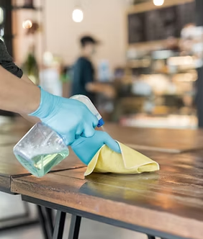
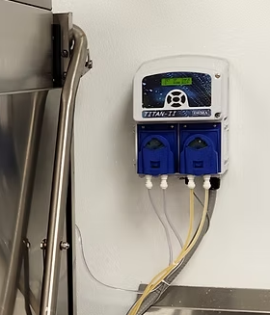
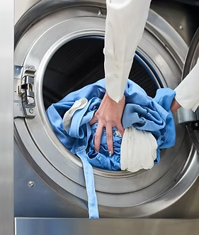
Our line of high-quality industrial disinfectants, floor care products, cleaners, and detergents provide excellent performance, coupled with amazing value. Whether you need dilution control or just looking for an all-purpose cleaner, we have what you need to get the job done right.
HAND HYGENE
FLOOR CARE
SURFACE
DELUTION CONTROL
FABRICS

EQUIPMENT________________________________________________________________________

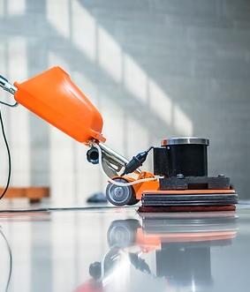
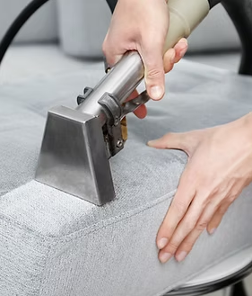
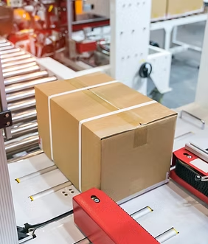
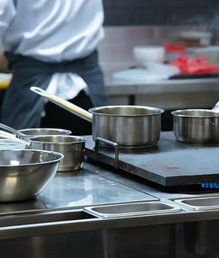
We have more than everything you need to build your janitorial, kitchen, laundry facility, warehouse, or other businesses. Our inventory features top-notch products such as dishwashers, floorcare appliances, strapping, packaging and food equipment.
DISHWAHERS
SCRUBBERS
VACUUMS
KITCHENWARE
STRAPPING

SERVICES__________________________________________________________________________
OUR BRANDS
All proportioners and dispensers are installed for FREE.

CLEANING CHEMICALS AND SUPPLIES_____________________________________________________
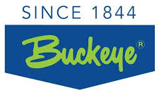

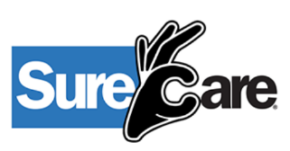

JANITORIAL_______________________________________________________________________________


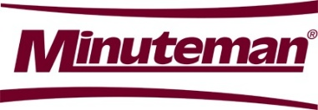





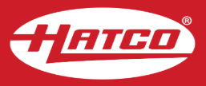
KITCHEN _________________________________________________________________________________




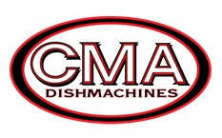

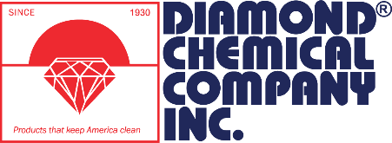
LAUNDRY _________________________________________________________________________________

WAREHOUSE _____________________________________________________________________________


DILUTION CONTROL
All proportioners and dispensers are installed for FREE.

PROPORTIONERS_________________________________________________________________________
BE031 - ECO PRO PROPORTIONER FREE
Broad spectrum cleaning for up to 6 products.

DISPENSERS______________________________________________________________________________
BE0215 - Symmetry® Hand Hygiene Dispenser - White FREE
1250ml dispensers contain silver ion, an antimicrobial agent approved by the FDA, EPA, and NSF.

BE0215 - Symmetry® Hand Hygiene Dispenser – Black FREE
1250ml dispensers contain silver ion, an antimicrobial agent approved by the FDA, EPA, and NSF.

CLEANING CHEMICALS
For easy chemical identification, we have ECO labeled spray bottles for $3 each

HAND HYGIENE___________________________________________________________________________
BE023 - Foaming Hand Sanitizer with Aloe and Vitamin E $155.50
Rich foaming, waterless hand sanitizer that reduces common disease-causing bacteria. It is formulated with 62% w/w (70% v/v) ethyl alcohol, aloe, and vitamin E leaving your hands refreshed — even with repeated use. FRAGRANCE: Sweet.
BE025 - Green Certified Foaming Hand Wash $89.40
Hand cleaner for general hand washing use that is biodegradable, free of all dyes, and certified by Green Seal™ to meet the GS41 standard. FRAGRANCE: Sweet. Our hand soap dispenser delivers just 0.6 ML per pump – one of the lowest portions in the industry – while still providing an effective hand wash.
BATHROOM AND ODOR____________________________________________________________________
BE082 - Dy-Phase $89.00
Fast acting, viscous, color-indicating bowl and urinal cleaner formulated for maximum cleaning and deodorizing. Upon application, the yellow color ensures that surfaces are completely covered. Then Dy-Phase will turn blue when surfaces are completely clean. FRAGRANCE: Pleasant.

BE086 - SPARKLE $90.65
Use on ceramic tile, porcelain, chrome, and stainless steel. If you have hard water film, rust, scale, or soap scum buildup that is hard to remove without damaging your chrome or stainless steel. Its 36% phosphoric acid formula quickly eliminates hard mineral films while its special wetting action easily dissolves soap scum.

SURFACE_CLEANERS______________________________________________________________________
E12 - ECO GLASS CLEANER HD $145.20
Glass Cleaner HD is dilutable for use on your glass, windows, mirrors, Plexiglas®, etc. It dries quickly, without streaking, reducing time and labor. Does not contain alcohol, butyl or ammonia, which may be hazardous to your employees and could damage surfaces. FREGRANCE: Ocean surf. PRODUCT SIZE: 4 X 1.25 L / Makes 90 qt per case. $1.52 per qt.

E14 - ECO MUSCLE CLEANER $156.20
Muscle Cleaner quickly liquefies and lifts soils for easy removal without hazardous ingredients. It removes graffiti, ball-point ink, permanent marker, crayon, pencil, black heel marks, food soils, grease, oil, dyes and most stains. No rinsing is required and no residue left behind. PRODUCT SIZE: 4 X 1.25L / Makes 48 end-use qt. $3.06 per qt.

E15 - ECO HYDROGEN PEROXIDE CLEANER $163.70
General purpose cleaner for use on floors, walls, fixtures, and many other surfaces. Apply with a cloth, sponge, trigger spray bottle, pump-up sprayer, automatic scrubber, foam gun or mop. FRAGRANCE: Orange blossom. PRODUCT SIZE: 4 X 1.25L / Makes 21.5 gal or 343 qt. $0.45 per qt.

E16 - ECO ACID CLEANER $116.45
Removes hard water deposits, standing water rings, and soap scum buildup from multiple surfaces. FRAGRANCE: Citrus Floral Wood. PRODUCT SIZE: 4 X 1.25 L / Makes 90 qt. $1.22 per qt.

E23 - ECO NEUTRAL DISINFECTANT $145.10
Multipurpose, neutral pH, broad-spectrum germicidal detergent designed for use in hospital, healthcare and industrial settings. It is ideal for routine germicidal cleaning and floor care maintenance - no rinsing is required. FRAGRANCE: Lemon Zest. PRODUCT SIZE: 4 X 1.25L / Makes 339 gal or 343 qt. $0.40 per qt.

E61 - ECO HEAVY DUTY CLEANER $128.10
Highly concentrated and removes soils from your walls, floors, and fixtures as well as food processing surfaces such as saws, grinders, baking pans, grills, and ovens. It is formulated for superior cleaning and soil suspension, works in both hot and cold water and is NSF registered. PRODUCT SIZE: 4 X 1.25L / Makes 170 gal or 174 qt. $0.70 per qt.

E62 - ECO SANITIZER $112.55
Super concentrated, broad-range sanitizer for your walls, floors and fixtures — to include food processing and preparation surfaces. Range of 150–400 ppm. PRODUCT SIZE: 4 X 1.25L / Makes 2709 qt. $0.04 per qt.

S12 - ECO GLASS CLEANER HD $94.40
Dilutable for use on your glass, windows, mirrors, Plexiglas®, etc. It dries quickly, without streaking, reducing time and labor. Does not contain alcohol, butyl or ammonia, which may be hazardous to your employees and could damage surfaces. FRAGRANCE: Ocean Surf. PRODUCT SIZE: 6 X 32 / Makes 102 end-use qt. $0.87 per qt.

S15 - ECO HYDROGEN PEROXIDE CLEANER $156.20
All-in-one solution for cleaning facilities without stocking multiple products. It is an environmentally responsible, general-purpose cleaner for use on floors, walls, fixtures, and many other surfaces. Apply with a cloth, sponge, trigger spray bottle, pump-up sprayer, automatic scrubber, foam gun or mop. FRAGRANCE: Orange Blossom. PRODUCT SIZE: 6 X 32 / Makes 386 gal or 390 qt. $0.38 per qt.

S31 - ECO PH NEUTRAL CLEANER $107.25
pH Neutral Cleaner on your floors, walls, fixtures and other hard surfaces where water is used. Apply it with a cloth, sponge, trigger spray bottle, mop and bucket, or an automatic scrubber. Formulated without APEO or EDTA, and is safe on floor finish at any concentration. FRAGRANCE: Lavender. PRODUCT SIZE: 6 X 32 / Makes 194 gal or 198 end-use qt. $0.51 per qt.

S61 - ECO HEAVY DUTY CLEANER $65.55
Highly concentrated and removes soils from your walls, floors, and fixtures as well as food processing surfaces such as saws, grinders, baking pans, grills, and ovens. It is formulated for superior cleaning and soil suspension, works in both hot and cold water and is NSF registered. PRODUCT SIZE: 6 X 32 / Makes 192 gal or 768 qt. $0.08 per qt.

FOOD SERVICE____________________________________________________________________________
BE0111 - Dysh $84.85
Concentrated, biodegradable, liquid detergent for hand washing dishes, glassware, pots, pans and silverware. Removes egg residue, grease, lipstick and milk rings. FRAGRANCE: Citrus. PRODUCT SIZE: 4 X 1 gal / Makes 2,048 end-use gal. $0.04 per gal.
BE0114 - SANI Q2 $101.80
Concentrated quaternary sanitizer and disinfectant developed for your food contact and non-food contact surfaces in any facility, restaurant, bar, federally inspected meat and poultry plant, and beverage plant. PRODUCT SIZE: 4 X 1 gal / Makes 2,048 end-use gal. $0.05 per gal.

FLOOR CARE______________________________________________________________________________
BE041 - CLARION 25 $153.65
Floor finish can be applied to all porous floors. It utilizes Microban surface modification technology that embeds an EPA registered antimicrobial into the floor finish. Maintains its high gloss with minimal maintenance.
BE0410 - PROCLAIM $226.20
Concrete floor coating is ideal for warehouses, manufacturing plants, loading and staging areas, retail facilities, and hard surface areas that get heavy traffic from forklifts, pallet jacks, rolling carts and other heavy equipment. Classified for slip resistance to provide safety.

BE061 - BASE HIT $150.40
Baseboard Stripping Gel penetrates and emulsifies stubborn floor finish buildup and heavy soils from your baseboards, resilient tile, and hard surface flooring. FRAGRANCE: Fresh.
BE066 - RIPSAW $173.20
Cuts through your floor finish buildup, and makes the labor intensive task of stripping easier and more manageable. You'll get the job done quicker by reducing the dwell time required, while still removing finish and sealer in one application. Use on all hard floor surfaces. FRAGRANCE: Mild, No Fragrance Added. PRODUCT SIZE: 5 Gal AP / Makes 20 end-use gal. $8.14 per gal.
BE093 - DEFOAM $123.70
Quickly and effectively eliminates foam in all types of recovery systems, so your equipment performs its best. Use Defoam in the recovery tanks of hot water extraction systems, wet/dry vacuums, and automatic scrubbers. FRAGRANCE: Mild/No fragrance added. PRODUCT SIZE: 4 X 1 / Makes 512 end-use gal. $0.23 per gal.
E33 - ECO FLOOR CLEANER $187.00
This cleaner is low-foaming, super concentrated, pH neutral when diluted so it will not damage your floor finish. Use on all types of floors. FRAGRANCE: Fruity Floral. PRODUCT SIZE: 4 X 1.25 L / Makes 677 Gal. $0.26 per gal.
E51 - ECO CARPET SPOTTER $290.85
Concentrated full spectrum spotter, effective on both your oil and water-based stains. Its encapsulation technology prevents re-soiling. FRAGRANCE: Fresh and Clean. PRODUCT SIZE: 4 X 1.25L / Makes 48 qt. $5.70 per qt.
E52 - ECO EXTRACT CARPET CLEANER $81.55
Its chemistry bonds with the oil, grease, dirt or other soil and removes it quickly with the aid of the hot water. Low foaming and leaves no residue. FRAGRANCE: Fresh and Clean. PRODUCT SIZE: 4 X 1.25L / Makes 170 gal. $0.45 per gal.
S32 - ECO FLOOR CLEANER FRAGRANCE-FREE $97.55
Low-foaming, super concentrated, fragrance-free floor cleaner for use on all types of floors. It provides superior cleaning ability and is pH neutral when diluted so it will not damage your floor finish. PRODUCT SIZE: 6 x 32 / Makes 770 gal. $0.12 per gal.
SPECIALTY CLEANERS, POLISHES, AND DETERGENTS______________________________________
BE0123 - GLINT $101.90
It cleans and polishes metal surfaces, effectively removing dirt and residue. Formulated for stainless steel surfaces, chrome, aluminum, brass, copper, and silver. FRAGRANCE: Pleasant.

BE0124 - STAR SPRAY $75.60
Ready-to-use glass cleaner for use on glass, windows, mirrors, Plexiglas®, plastic, glossy paint, stainless steel, counter tops, Formica®, etc. Remove smudges and fingerprints from chrome, stainless steel, plastic and painted surfaces. Formulated without alcohol, butyl or ammonia—ingredients that may be hazardous to your employees and surfaces. FRAGRANCE: Citrus.
PET CARE_________________________________________________________________________________
BE018 - Watchdog NF $149.20
One-step disinfectant, cleaner and deodorizer designed specifically for the pet care industry. Use on hard, nonporous surfaces. PRODUCT SIZE: 4 X 1 / Makes 32 end-use gal. $4.38 per gal.

LAUNDRY CHEMICALS
*Using our bleach, detergent, and fabric softener costs just $3.10 per load.

DETERGENTS______________________________________________________________________________
BC001 Simplicity Ultra Detergent* $370.55
For medium soil this product uses 3 oz per 100lbs of linen. $0.58 per oz.

BLEACHES________________________________________________________________________________
BC002 Color Safe Bleach $184.25
For medium soil this product uses 5 oz per 100lbs of linen. $0.29 per oz.

BC003 Chlorine Bleach* $125.65
For medium soil this product uses 4 oz per 100lbs of linen. $0.20 per oz.

SOFTENERS_______________________________________________________________________________
CL001 Fabric Softener* $175.00
For medium soil this product uses 2oz per 100lbs of linen. $0.28 per oz.

CLEANING SUPPLIES
You can find other cleaning supplies on our website www.TrustySupply.com today!

GLOVES___________________________________________________________________________________
4 Mil Nitrile – Indigo $78.00
Case of 1,000. $0.08 per glove.

4 Mil Vinyl Gloves - Blue $51.00
Case of 1,000. $0.05 per glove.
4 Mil Vinyl Gloves - Clear $54.00
Medical grade. Case of 1,000. $0.05 per glove.

5 Mil Prem. Nitrile - Blue $72.00
Case of 1,000. $0.07 per glove.

5 Mil Stand. Nitrile - Black $79.00
Case of 1,000. $0.08 per glove.

6 Mil Nitrile - Orange $104.00
Case of 1,000. $0.10 per glove.

7 Mil Deluxe Nitrile - Black $110.00
Case of 1,000. $0.11 per glove.

7 Mil Deluxe Nitrile - Green $115.00
Case of 1,000. $0.12 per glove.

8 Mil Extend Cuff - Blue $96.00
Case of 500. $0.19 per glove.

